VS Code Installation

**Big Ideas  
Tools and technologies can be adapted for specific purposes.**

As you begin your journey in this course, think carefully about the tools you use to program. A carpenter, a bricklayer, a painter… all these people need tools in order to create and build. In much the same way, a computer programmer requires tools to create and build programs.

The VS Code is a tool that programmers can use to create computer software. Just like how a saw or a hammer or a paint brush can be used to create a wide variety of things, VS Code can be used to create a wide variety of software applications.

1. Java in Visual Studio Code

VS Code provides extensive documentation on using Java with VS Code. Navigate <https://code.visualstudio.com/docs/languages/java>. Here you will find the Windows and MacOS: Installer of Visual Studio Code for Java developers links:

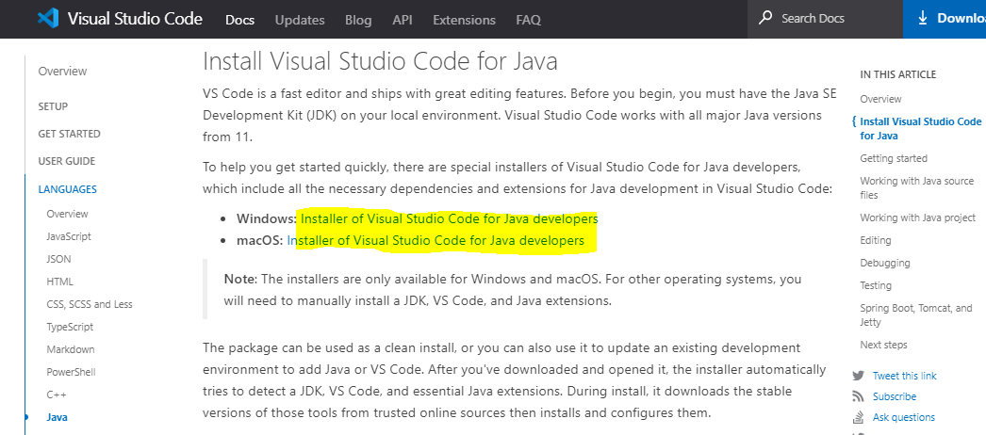

After clicking the appropriate download for your operating system, open the VSCodeJavaInstaller file. Once you agree to the licensing terms, the installer will automatically detect the JDK, VS Code and Java extensions.